Department of Medical Parasitology
Sohag Faculty of Medicine
Sohag University

Practical Parasitology

For
3rd year medical students
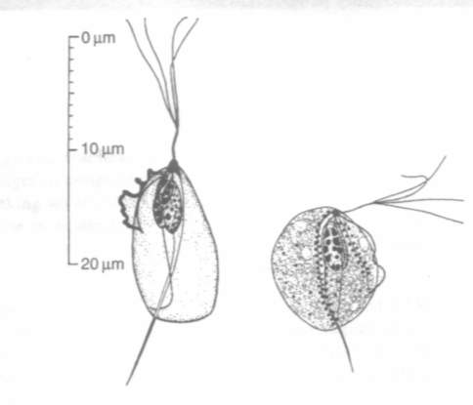
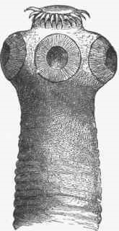
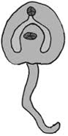
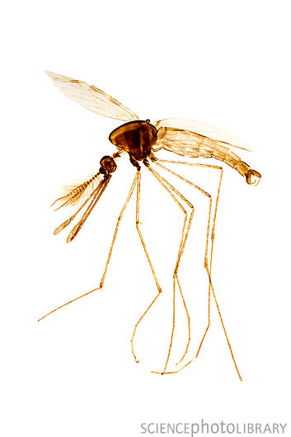

BY

Members of Medical Parasitology department
2014-2015

Helminthology

Platyhelminthes

Class: Trematoda
Genus: Fasciola
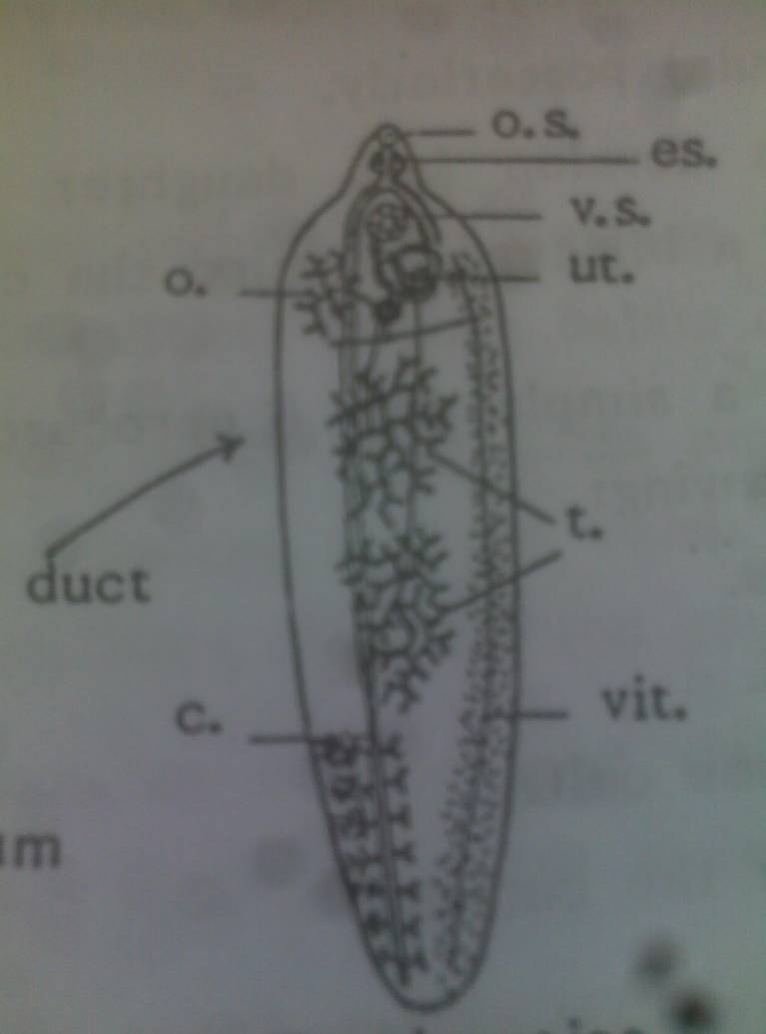
- Fasciola gigantica: (Mature, on a slide)
* Large (3-8 cm).
* Leaf-like with anterior cone & nearly parallel margins.
* Oral sucker anterior.
* Large ventral sucker.
* Muscular pharynx & 2 branched intestinal caeca.
* 2 branched testes.
*Small follicles of vetlline glands, one branched ovary and a coiled uterus

- Fasciola hepatica: (Mature, on a slide)
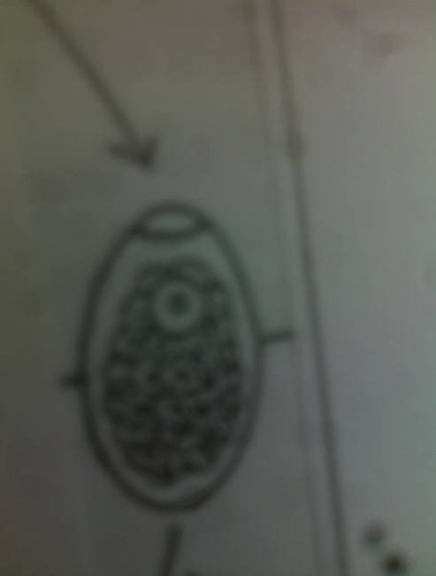
*Smaller (2-3cm X 1-1.3cm).
* Larger ant. Cone.
* Converging lateral margins.
* Oral & vent. Suckers are nearly equal
Fasciola egg:
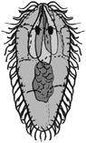
* Large size (130-190X 60-90µ)
* Oval & operculated.
* Yellowish, thin shelled and contains immature contents.

Fasciola miracidium:
* Pear shaped & ciliated.
* Has an ant. Cone, primitive gut, 2 penetration glands, 2 flame cells, 2 eye spots & germ cells.
Fasciola cercaria:
* 1mm. Long.
* Heart shaped body (1/3) and a simple tail (2/3). (Leptocercous).
* Oral and ventral suckers.
* 4 layers of cystogenous glands.
* Alimentary glands.

Heterophyes heterophyes
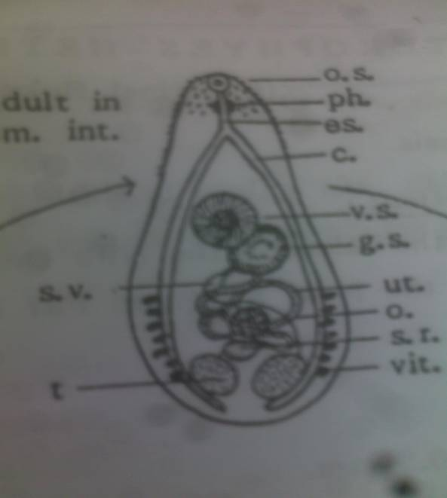
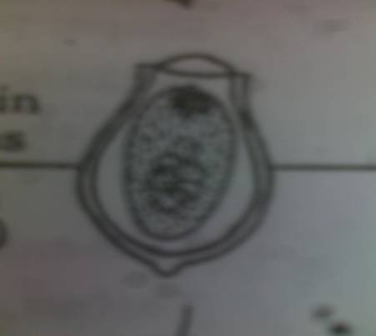
Mature worm:
* Small, 1-3mm long X 0.3-0.5 in width. It is pear shaped.
* Oral, ventral and Genital suckers.
* Has 2 simple tubular blind-ending intestinal caeca.
* 2 ovoid testes, small ovoid ovary, coarse few vetelline glands.
* Coiled uterus.

Egg:
* Small, 30 X15 µ, oval in shape & yellowish in colour.
* Thick shelled, operculated with a knob-like thickening at the opposite side.
* Immature miracidium.
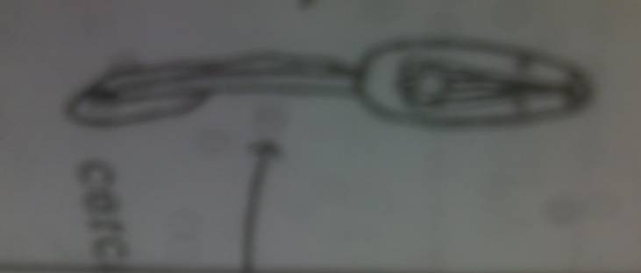
Cercaria:
* 1 mm long, with a simple tail, partially covered with a membrane.
* 2 eye spots.

Schistosoma mansoni
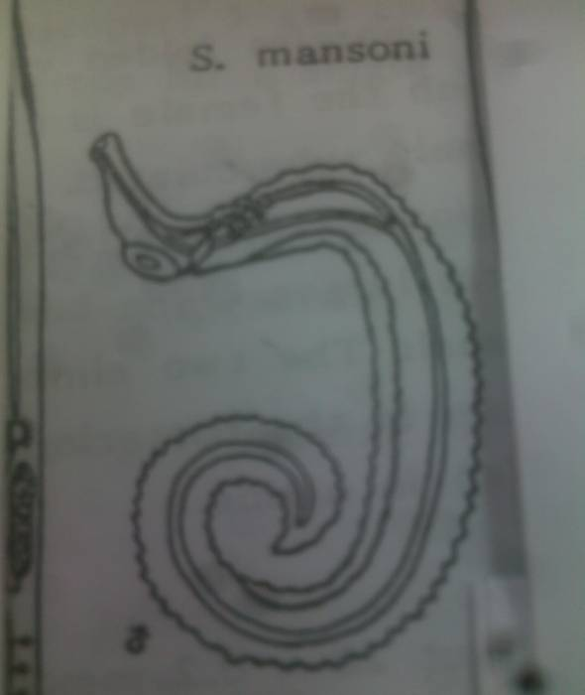
Male:
* Covered with coarse tubercles.
* 8 × 1 mm. in size.
* Has 6-9 testes.
* The intestinal caeca reunite in the anterior half of the body.

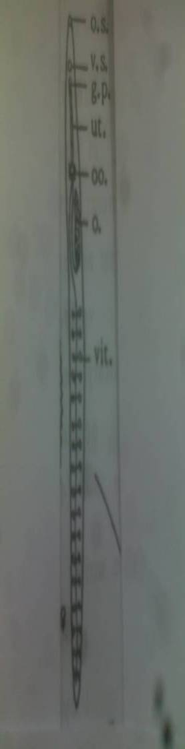
Female:
* Smooth, ovary in the anterior third of the body.
* 14 × 0.15 mm.
*Vitelline glands are numerous.
* The uterus is short, containing usually one egg.

Egg:
* Large: 160X60µ, thin shelled, non operculated with a lateral spine.
* It contains a mature miracidium.
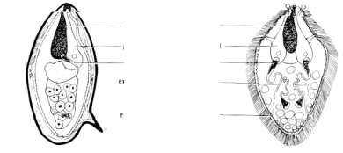
Schistosma mansoni egg schistosoma miracidium

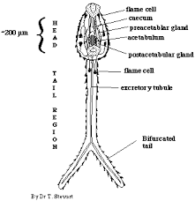
Cercaria:

* The tail is furked (furcocercous).
* 2 suckers and 5-6 pairs of penetration glands.

Schistosoma haematobium

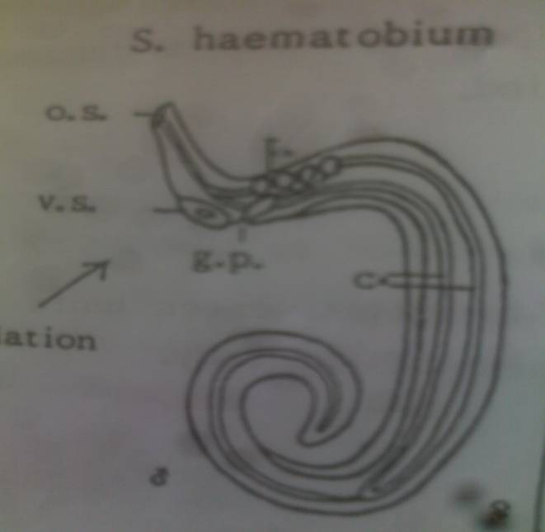
Male:

* 10 × 1 mm.
* Covered with fine tubercles.
* Has 4-6 testes.
* The intestinal caeca reunite in the posterior half of the body.

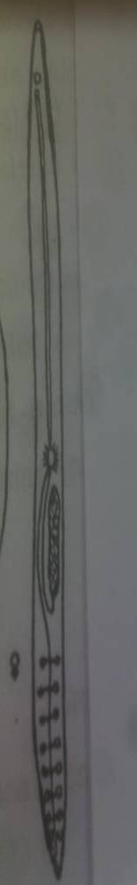
Female:
* Smooth, ovary in the posterior third of the body.
*Vitelline glands are less numerous.
* The uterus is long, containing usually groups of eggs.
* 20 × 0.2 mm.

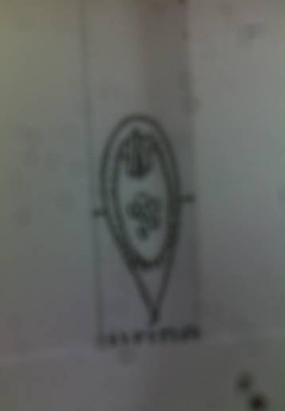
Egg:

* Spindle-shaped, 140X50µ.
* Thin-shelled, translucent.
* Has a terminal spine.
* contain mature miracidium.

Some Egyptian Snails of
Medical importance

Introduction :
* The snail is the hard outer skeleton of the soft mollusk animal.
* The empty snail is put facing the examiner.
* Apex, base, spire, aperture and whorls are to be studded and described.
Dextral snails:
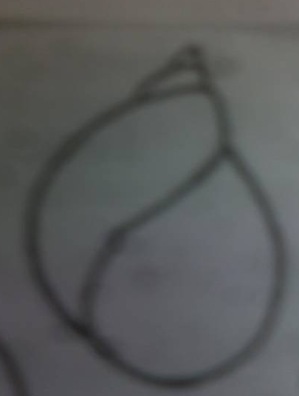
Lymnaea cailliaudi:
* One fragile body whorl and sharp apex.
* A wide aperture.

Cleopatra bulimoides:
* Of veterinary importance.
* Brownish, small and oblique body whorls.
* Blunt apex, shallow sutures, dark bands in the middle and an umbilicus.
Cleopatra cyclostomoides:
* Similar to the former, but whitish in colour and has a smaller umbilicus.
Vivipara unicolor:
* Similar to the former in shape and veterinary importance.
* Differs in the sharp apex, deep sutures, convex whorls.
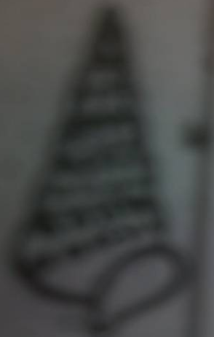
* Has a small umbilicus
Pirenella conica:
* Medium sized, long spire and a sharp apex.
* Slightely oblique body whorls and course tubercles arranged in 1-4 rows.
* The aperture has a syphonal notch.

Melania tuberculata:
* Similar to the former, but, more oblique body whorls and deep sutures.
* fine tubercles in several rows.
*No syphonal notch.
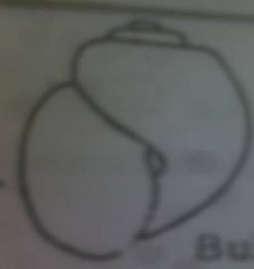
* Intermediate host for bird Schistosoma.
Sinistral snails:
Bulinus truncatus:
* Small-medium sized, thin and fragile shell.
* Blunt apex & a short spire.
* One large body whorl, deep sutures and an umbilicus.

Physa acuta:
* Small, one body whorl, sharp apex and no umbilicus.
* Intermediate host for bird and animal trematodes.

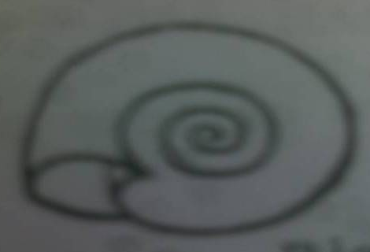
Biomphalaria alexandrina:
* Small sized and a discoid shell.

Lanistes bolteni:
* Large sized, no medical importance.
* Blunt apex, short spire, deep sutures and convex whorls.
* A large umbilicus and a wide aperture.

